**ONE CREDIT COURSE**

**PYTHON -DATA ANALYTICS**

**NAME: NIVETHA M**

**REG NO:927621BIT082**

**M.KUMARASAMY COLLEGE OF ENGINEERING ,**

**KARUR**

**1.Salary dataset**

import pandas as pd

import numpy as np

dataset=pd.read_csv("Salary_dataset.csv")

dataset

x=dataset.iloc[:,0:1]

dataset

y=dataset.iloc[:,1]

dataset

from sklearn.model_selection import train_test_split

x_train,x_test,y_train,y_test = train_test_split(x,y,train_size=0.8,random_state=42)

from sklearn.linear_model import LinearRegression

model = LinearRegression()

model.fit(x_train,y_train)

samplepredciton = model.predict([[1.2]])

print(samplepredciton)  
  
  
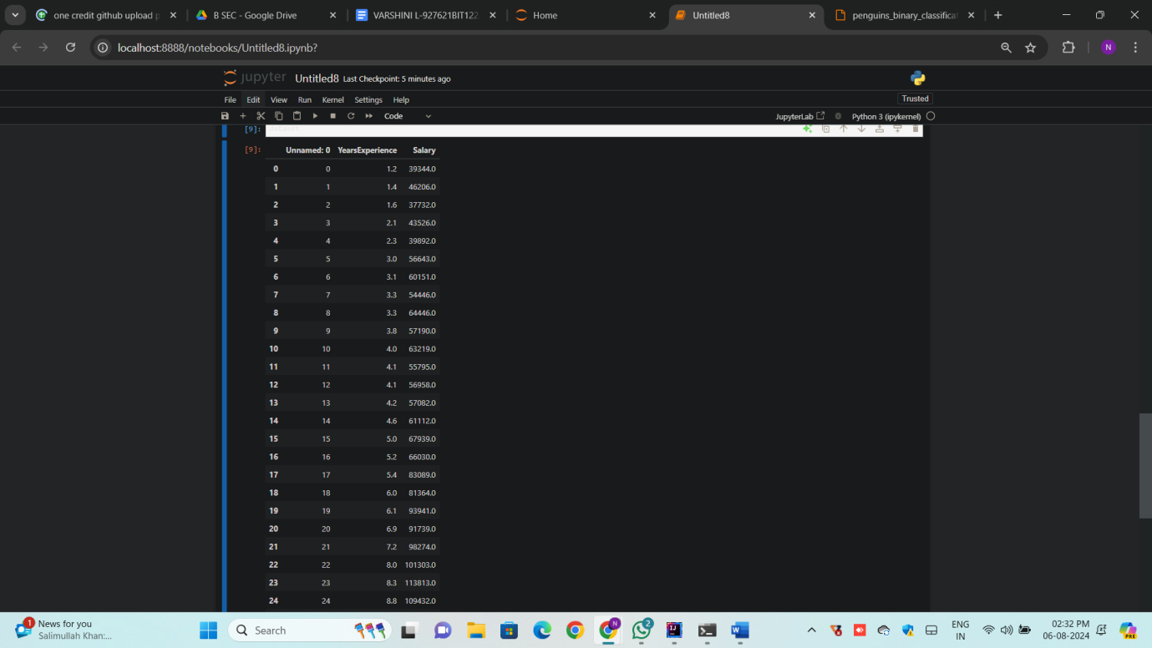

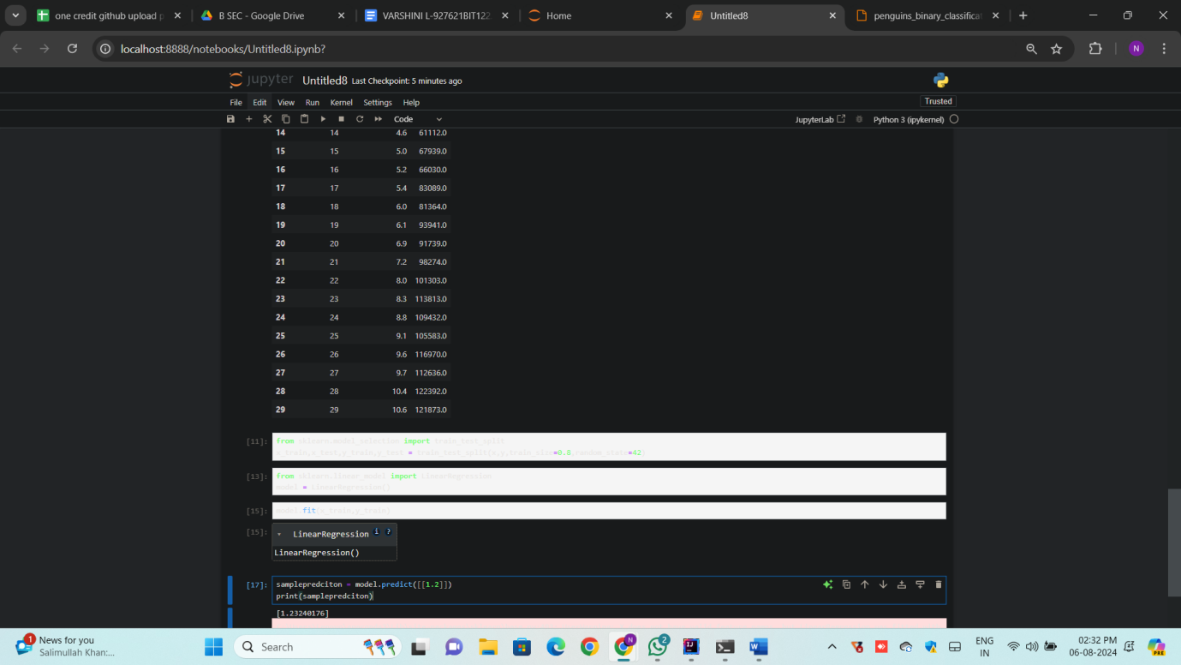

**2.penguins_binary_classification**  
  
import numpy as np

import pandas as pd

dataset = pd.read_csv("penguins_binary_classification.csv")

# first we need upload the datasetdataset.head(100)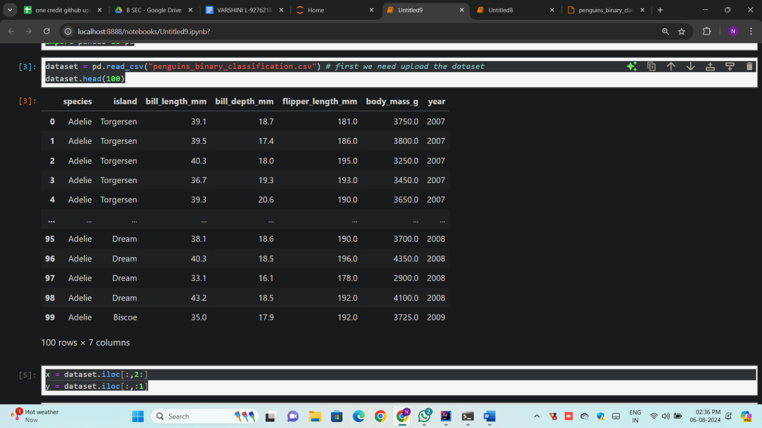

x = dataset.iloc[:,2:]

y = dataset.iloc[:,:1]

x

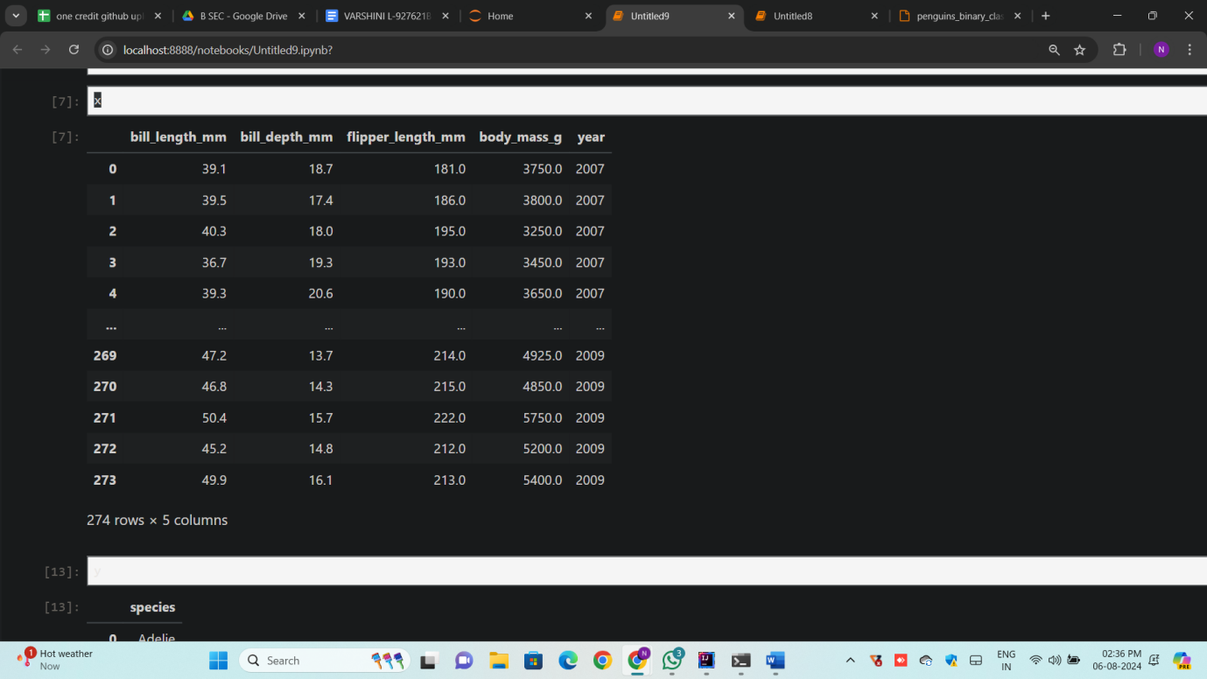

y

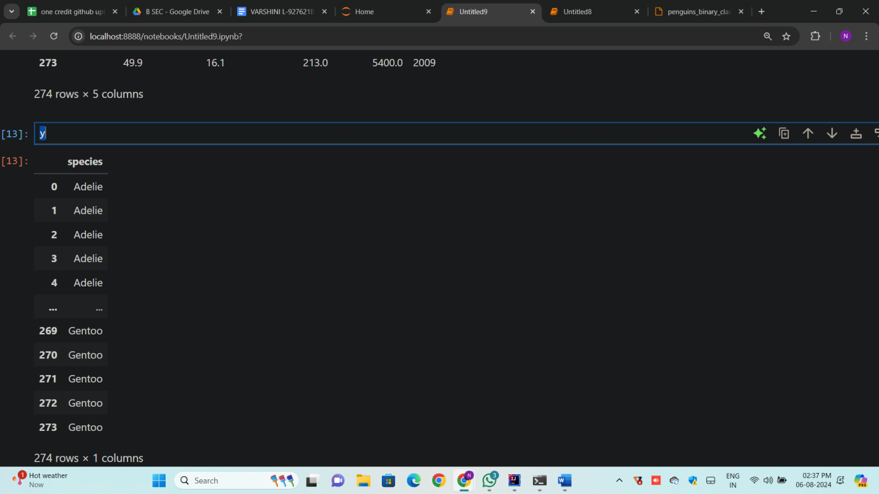

from sklearn.model_selection import train_test_split

x_train,x_test,y_train,y_test = train_test_split(x,y,train_size=0.8,random_state=42)

from sklearn.linear_model import LogisticRegression

model = LogisticRegression()

model.fit(x_train,y_train)

